TITLE
(TIMES NEW ROMAN, 14 FONT SIZE, BOLD, ALL CAPS, CENTERED)

Author’s Name and Surname¹,Author’s Name and Surname^{2,} (12 font size)
¹Affiliation, Email, ²Affiliation,Email

Abstract: Abstract should be written with 10 font size, Times New Roman, single line spacing. Summarize in this section objective, method and findings/conclusions.

Keywords: This section should contain maximum 6 words separated by commas.

GENERAL GUIDELINES
Papers should be submitted electronically (in Word format, .docx) in English, Spanish or Portuguese at http://sgc.wikibrasil.org.
The paper must contain the following sections: abstract (approximately 100 words for posters and 200 words for papers) and keywords, introduction, methodology, findings, concluding remarks, and references. Section can be named differently and subsections can be included. Papers and Posters in Spanish or Portuguese should include Title, abstract and keywords in English.
The final paper shall be written in font Time New Roman, single line spacing and 12 font size. The final paper should contain a minimum of 7 and a maximum of 10 pages. Page format should be A4 page size with margins 2.5 cm wide from the right, left, top and bottom. Pages should not be numbered. No headers and footers should be included in the document.
All the tables, images and figures should be centered. Figures and images should be numbered (see Figure 2 for an example) and figure headers should be placed under the figure or image; as for the tables, they should also be numbered (see Table 2 for an example) and the table header should be placed at the top. References (if any) of the tables, figures and images should be presented right under the tables, figures and images in the form of author surname and publication date.

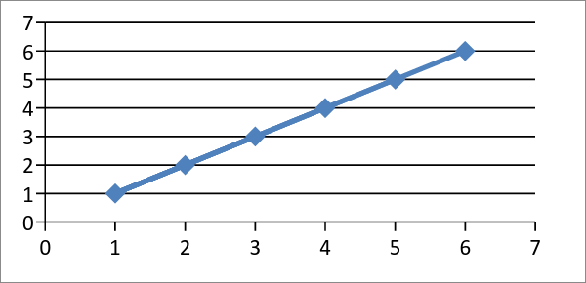

Figure 2. Header

Table 2. Header
Reference: author surname and publication date

INTRODUCTION (and all section headings: Times New Roman, 14 font size, bold, all caps)
The introduction section should (1) present the scope and objective of the paper and state the problem, (2) briefly review the pertinent literature, (3) describe the methods, and (4) provide an overview of the main results of the work.

METHODOLOGY
The methodology must be clearly stated and described in sufficient detail or with sufficient references. The author shall explain the research question, describe the research framework, and the methods applied in detail. It should be furthermore highlighted why the research question is relevant to theory and practice, and why the chosen method(s) are suited for the problem.

FINDINGS
The arguments and findings are described in detail in this section.

CONCLUDING REMARKS
Conclusions should include (1) the principles and generalisations inferred from the results, (2) any exceptions, problems or limitations of the work, (3) theoretical and/or practical implications of the work, and (5) conclusions drawn and recommendations.

REFERENCES
References should be listed in alphabetical order and presented in a format according to the APA Manual of Style 6th edition: http://www.apastyle.org/manual/

